Logistic Assets — App Documentation
Oct 29, 2026 · @Alaa Alzaybak

Overview
Logistic Assets is Basmeh & Zeitooneh's web system for tracking every physical asset the organization owns, from the purchase request that buys it to where it sits today. Furniture, appliances, machines, vehicles, electronics and IT equipment are recorded per location, with their status, donor and full change history.
The same application serves two portals, chosen by the web address you open:
Portal | Who uses it | What it covers
Logistic Assets | Super admins, logistics (location) admins, PR admins | Assets, purchase requests, approvals, location admins, reference data
Donors portal (Donor Management, donors.bzassets.org) | Finance users only | Donors, their policies and documents, and the assets they fund
The app is a single-page web application (Angular) talking to a REST API (PHP, Laravel). It works in any modern browser on desktop and phone, and offers two visual designs, Classic and BZ, that any user can switch between.

Roles and permissions
Every user has exactly one role, and the role decides which menu items appear and which actions the server accepts.
Role (shown in the app as) | Main screens | What they can do
Super admin (Pro Admin) | Dashboard, PR Edit Requests, Asset Edit Requests, Assign Location Admins, References, All Assets, Categories | Approve or reject asset and PR edit requests; manage locations, brands, suppliers and floors; assign logistics admins to locations
Logistics admin (Log Admin) | Dashboard, Purchase Requests, Location Change Requests, All Assets, My Assets, Categories | Create assets, import assets from Excel, request asset edits, update photos, request and approve location changes for their own locations
PR admin (Pr Admin) | Purchase Requests (no sidebar) | Create purchase requests and request changes to existing ones
Finance (Finance) | Donors portal: Donors; plus Dashboard and All Assets | Manage donors, their policies and documents; view all assets read-only
A logistics admin only sees assets, purchase requests and requests for the locations assigned to them. A location has at most one logistics admin: assigning a location to someone removes it from its previous admin.
Roles are stored on the user record. The Log Admin role is given through Assign Location Admins; the other roles are currently set directly in the database by a developer.

Getting started
Sign in with your work email and password; the app then opens the right home screen for your role.

Signing in
- Open the app (logistic.bzassets.org, or donors.bzassets.org for finance).
- Enter your work email and password, then select Continue (BZ design) or Sign In (Classic design).
- You land on your home screen: the Dashboard for super admins and logistics admins, Purchase Requests for PR admins, Donors for finance.
Accounts are created automatically from the HR system, with a shared starting password. Change it the first time you sign in (see below). If sign-in fails, the message tells you why: "This email is not registered" or "Incorrect password". The Donors portal refuses anyone who is not a finance user.
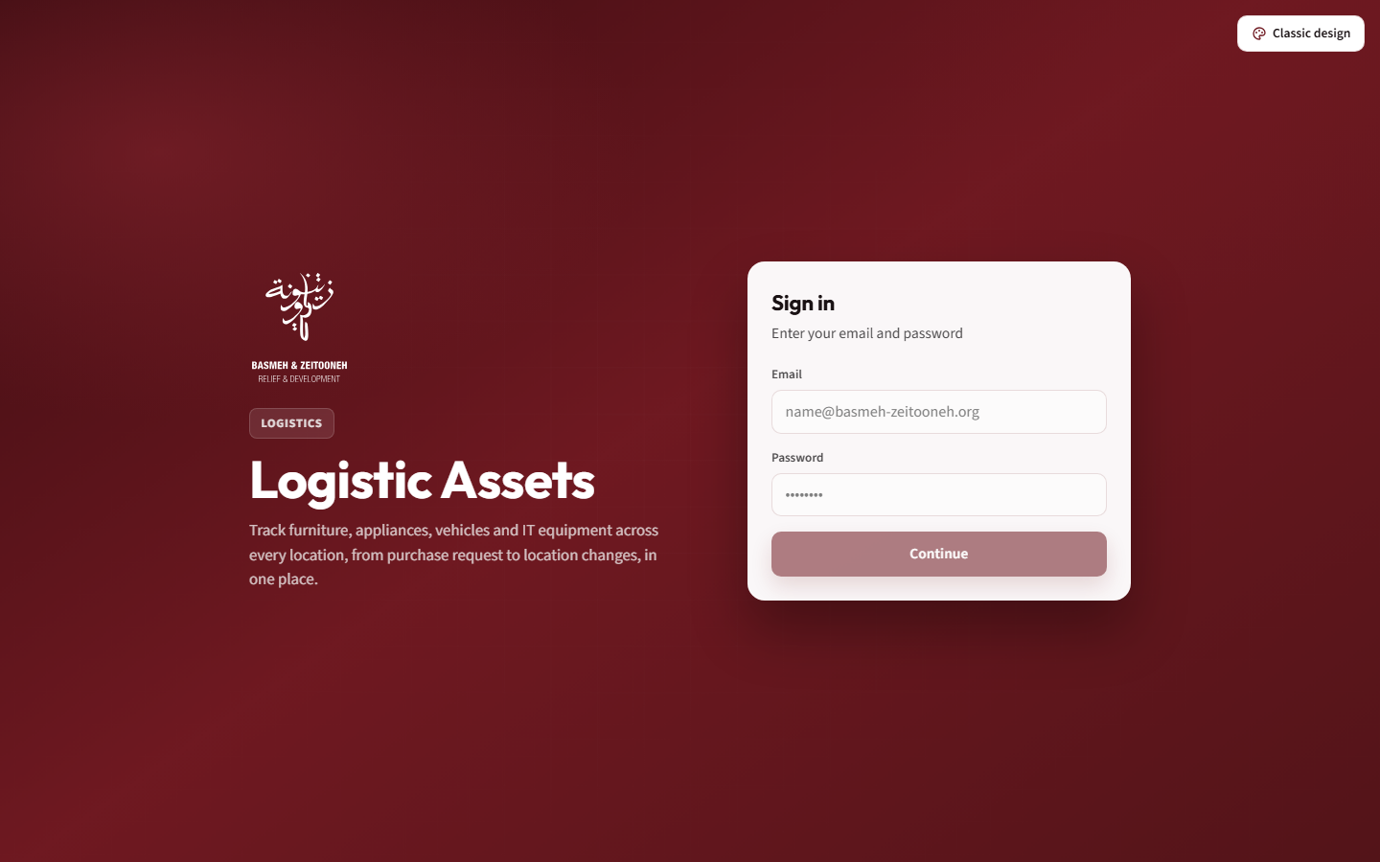
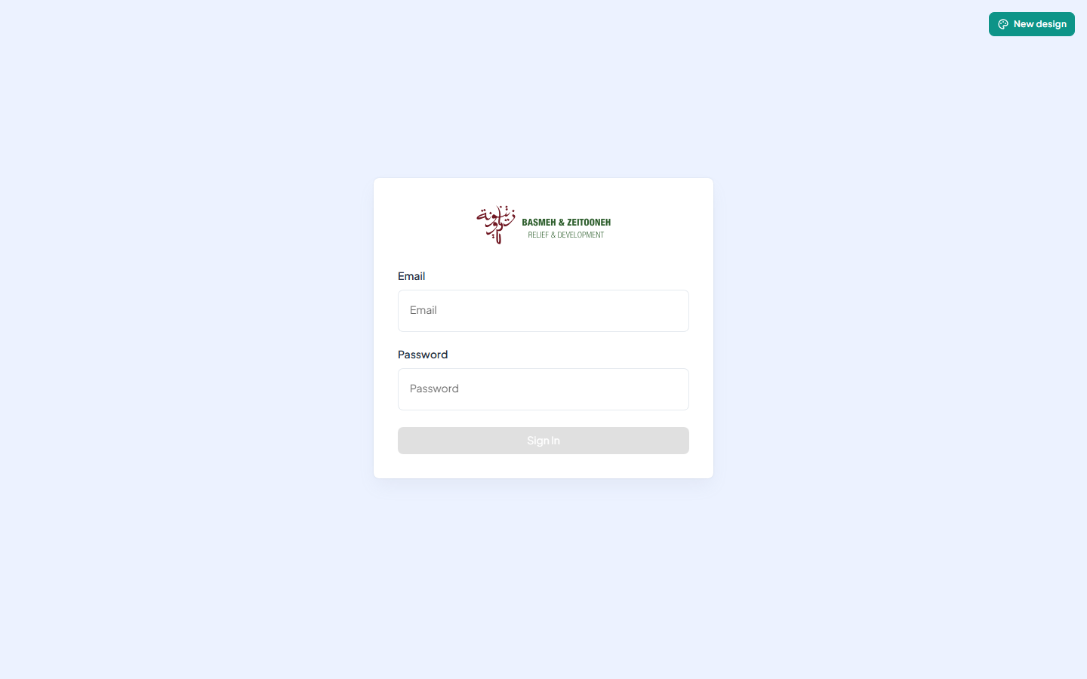

Choosing a design
The app has two looks with the same features: BZ (Basmeh & Zeitooneh brand, white sidebar, burgundy accents) and Classic (dark sidebar, teal accents). Switch with the design button in the top-right corner: it reads Classic design in BZ and New design in Classic. The choice is saved in your browser, so each computer or phone remembers it separately. New users start in BZ.

Your profile, password and logout
Select your name at the bottom of the sidebar (BZ) or your avatar in the top bar (Classic) to open your profile. It shows your email, your role and, for logistics admins, the locations assigned to you.
- Change Password: enter your current password, a new one of at least 6 characters, and confirm it.
- Logout: returns you to the sign-in page. On the main site it does not yet end your session, so on a shared computer also close the browser.
Your session renews itself in the background, so you normally stay signed in on that browser.

Notifications
The bell in the top bar shows how many notifications you have not read; it refreshes every 30 seconds. Select it to open the Notifications page, filter by All, Unread or Read, and use Mark All as Read. You are notified when a request you submitted is approved or rejected, and when a request is waiting for your approval.

On a phone
Everything works on a phone. Select the menu button at the top left to open the sidebar; it closes again when you pick a page.

Using the app
Asset data only changes through logistics admins, and every edit to an existing asset or purchase request waits for approval before it takes effect.

Dashboard
Seven cards show how many assets exist per category: Furniture, Appliances, Machines, Vehicles, Electronics, Computers and IT Equipment. Select a card to open the asset list filtered to that category; a faded card has no matching category yet. Below, the chart Assets by Location & Category compares locations, one bar per category; hover a bar for its count.

Browsing assets
Open All Assets, or pick a category under Categories in the sidebar.
- Filters: Status and Location always; Sub-Category and Item once a category is chosen; then one filter per attribute of that category (for example size or material), which also adds a column.
- Table: ID, Serial Number, Item, Acquisition Date, Status, Location, Brand, Donor (with its policies) and Owned By (B&Z or Landlord). Select a column header to sort, and a row to open the asset. Show 10, 25, 50 or 100 per page.
- Logistics admins see every asset here; My Assets shows only their locations.
Statuses are Functional, New, Damaged, Lost, Donated, Stolen and Transferred.

Importing assets from Excel
Select Import Excel on the asset list and choose an .xlsx or .xls file of up to 50 MB. Each worksheet holds one category and must be named exactly like it, with column headers in row 1. A row with a serial number that already exists updates that asset instead of adding a duplicate. When it finishes, the app reports how many rows were added, updated and skipped. The full column list is in the Technical guide; ready-made templates are in the Docs folder (Assets_Template_ updated final.xlsx).

Asset details
The asset page shows the photo, the main facts (serial number, category, location, holder, cost, supplier, brand, warranty), the detailed specifications (colour, purchase request, donor and its policies, budget code, floor, owner, attributes, notes) and the Asset Lifecycle: every event from creation through edits and moves, with who did it and when.
Only the logistics admin of the asset's location can change it; everyone else sees the page read-only.
- Photo: select the photo, or Upload Photo, and choose an image under 5 MB. Photos change immediately, without approval.
- Edit Asset: change the fields, then Submit for Review. The change goes to the super admins as an edit request, and a banner shows it is pending; the asset itself does not change until a super admin approves it. Category, item and location cannot be changed here.
- Move Asset: pick the new location and add a note. If you also manage the new location, the asset moves at once; otherwise the new location's admin must approve the move. Only one pending move or edit per asset is allowed at a time.

Creating an asset (logistics admins)
Select Create Asset on the asset list. The form has five steps; Next Step unlocks once the current step is complete.
- Classification: Category, Sub-Category, Item Type, and the category's attributes.
- General Info: Serial Number (optional, must be unique), Supplier, Brand, Color, Purchase Request, Acquisition Cost; optionally the acquisition and warranty dates. Purchase requests with no items left are greyed out.
- Assignment: Location (only yours), Floor, Status, Owned By (B&Z or Landlord), and optionally the person holding it.
- Extra Info: Description, Notes, Budget Code, Donor (its policies appear when chosen), and a photo.
- Review & Confirm: check everything, then Create Asset.
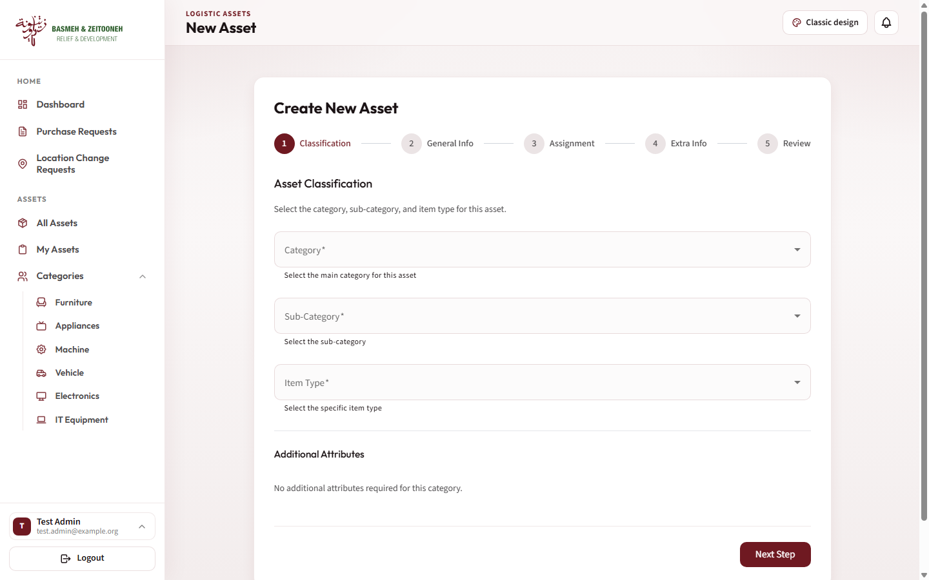

My Assets and location requests (logistics admins)
My Assets lists only the assets at your locations, with category counts on top, a search by name or serial, a status filter and sorting.
Location Change Requests lists moves into your locations that wait for you. Pending is shown by default; you can also filter Approved, Rejected or All. Use Approve to move the asset, or Reject with an optional reason. The requester is notified either way.
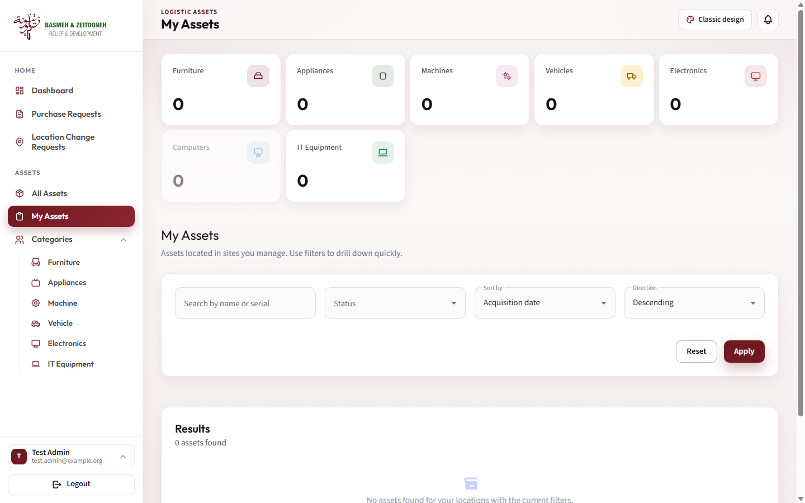

Purchase requests (PR admins and logistics admins)
Each asset is linked to the purchase request (PR) that bought it, and each PR line is one asset.
- List: search by code, see each PR's date, total, location, items (View Items) and document (View Document). Logistics admins see only their locations' PRs.
- Create PR: enter the PR Code (unique), PR Date and Location, then add one line per item with Category, Sub-Category, Item, Supplier and Unit Cost in USD. Attach the PR document (PDF, JPG or PNG, up to 20 MB) and select Submit PR.
- Edit: the pencil icon opens the PR for changes. Give a reason of at least 10 characters, change the details or lines, optionally replace the document (PDF, DOC or DOCX, up to 10 MB), and Submit Changes. This sends an edit request to the super admins; the PR changes only after approval.
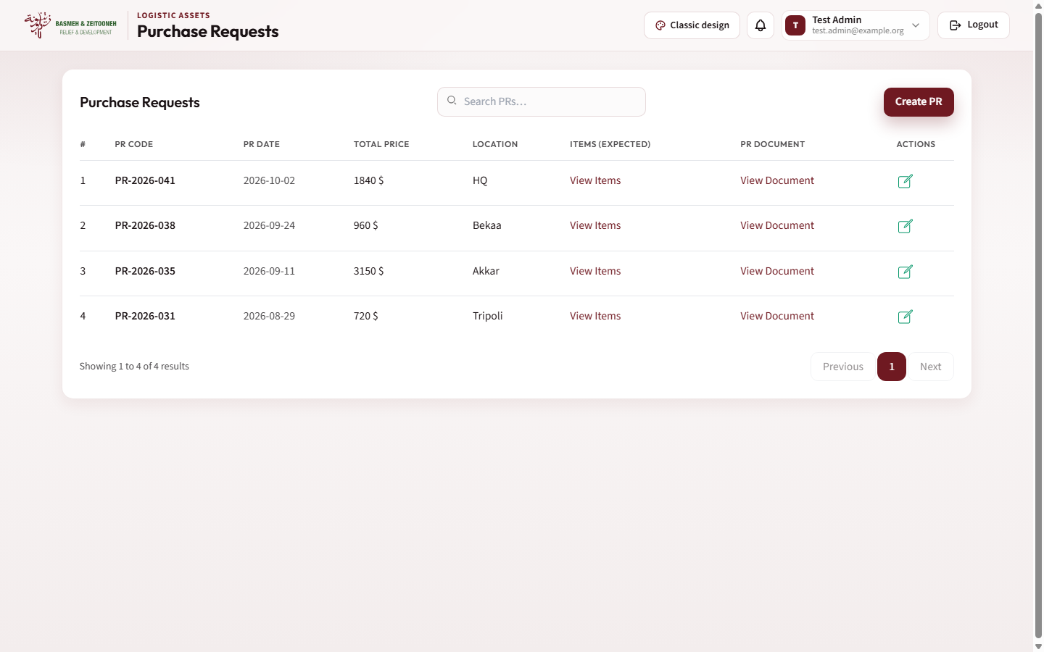
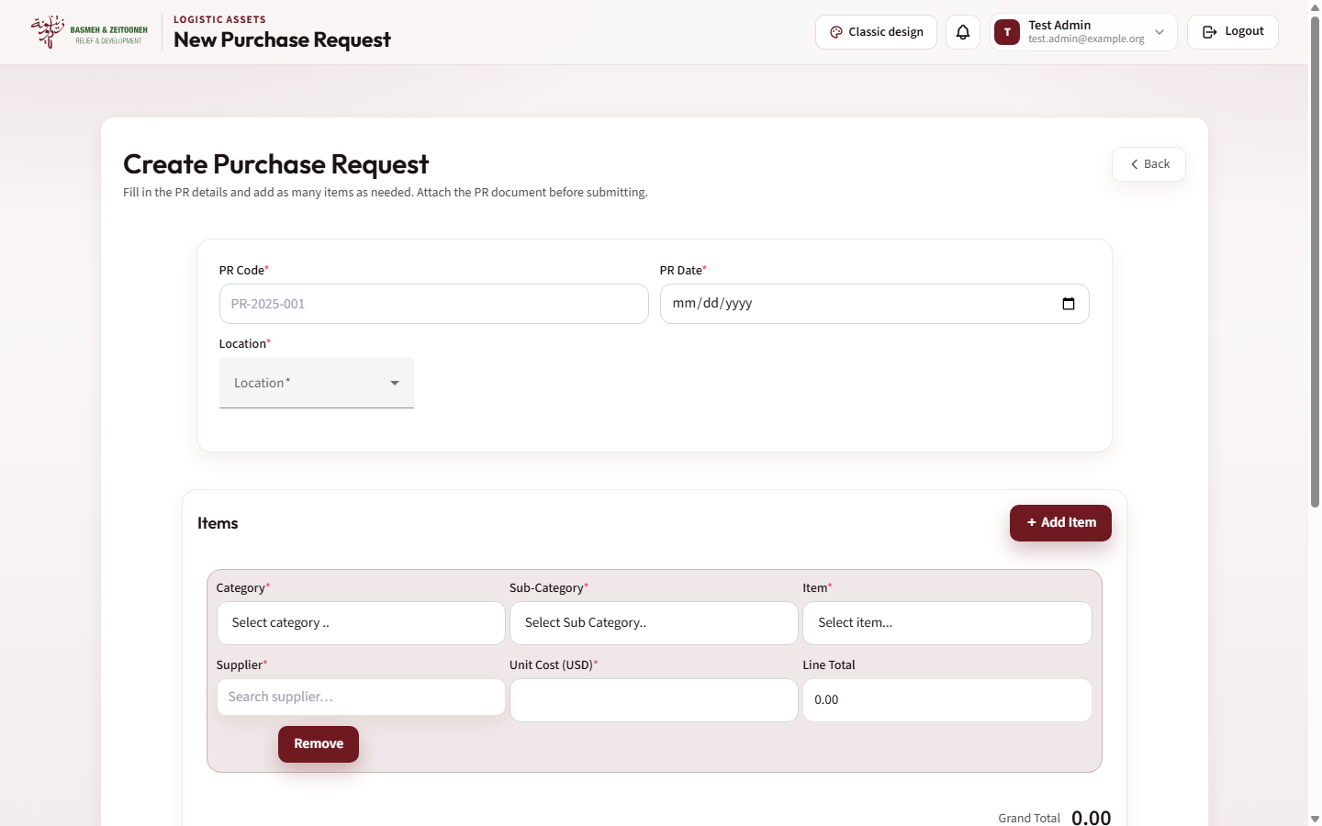

Approving changes (super admins)
Asset Edit Requests and PR Edit Requests list the changes waiting for you, Pending by default. Select Review to see the current and proposed values side by side, then:
- Approve & Apply (assets) or Approve (PRs) to apply the change at once.
- Reject, with an optional reason for assets, to discard it.
The person who asked is notified of your decision.
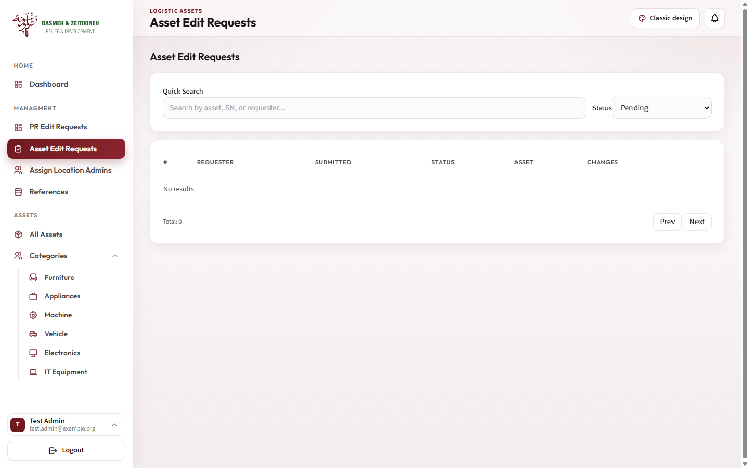

Assigning location admins (super admins)
Open Assign Location Admins. The top card lists current logistics admins and their locations. To assign:
- Search for a person (at least 2 characters of their name, email or employee id).
- Select them and choose the locations they will manage.
- Select Assign locations.
The person becomes a logistics admin, and anyone who managed those locations before loses them. The change applies at their next sign-in.
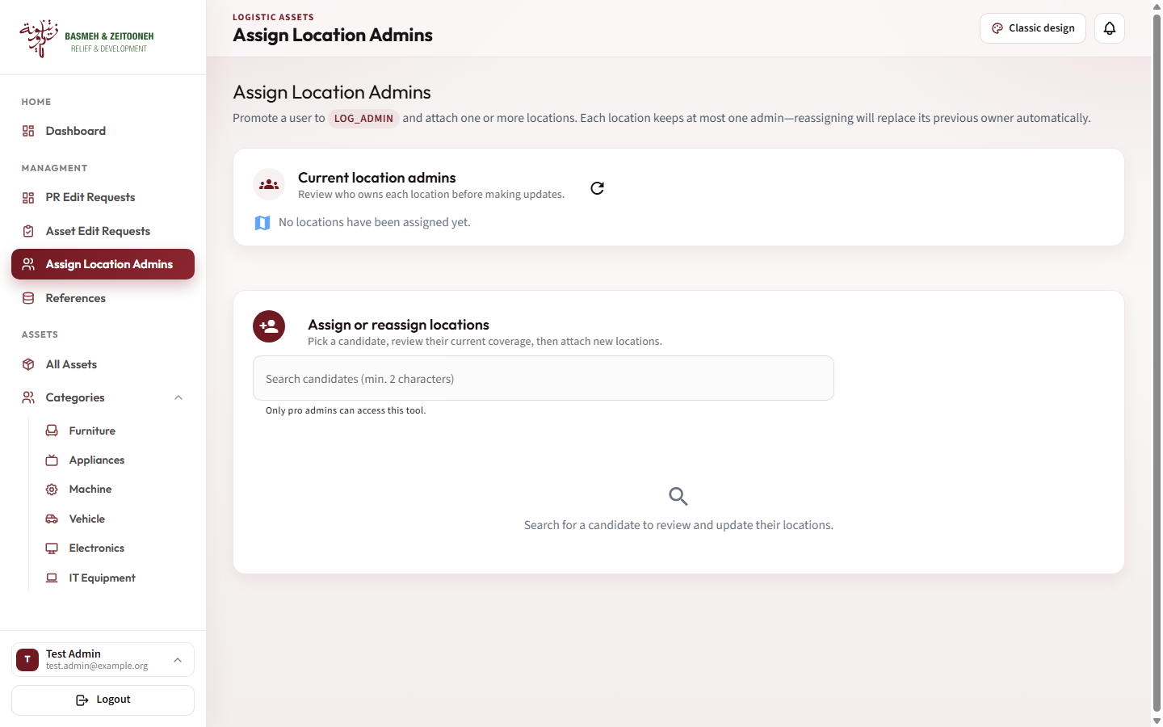

Reference data (super admins)
References has four tabs: Locations, Brands, Suppliers and Floors. Search a tab, add an entry with Add, or use the edit and delete icons on a row. Categories, items, attributes, colours and statuses are fixed and set up by developers.
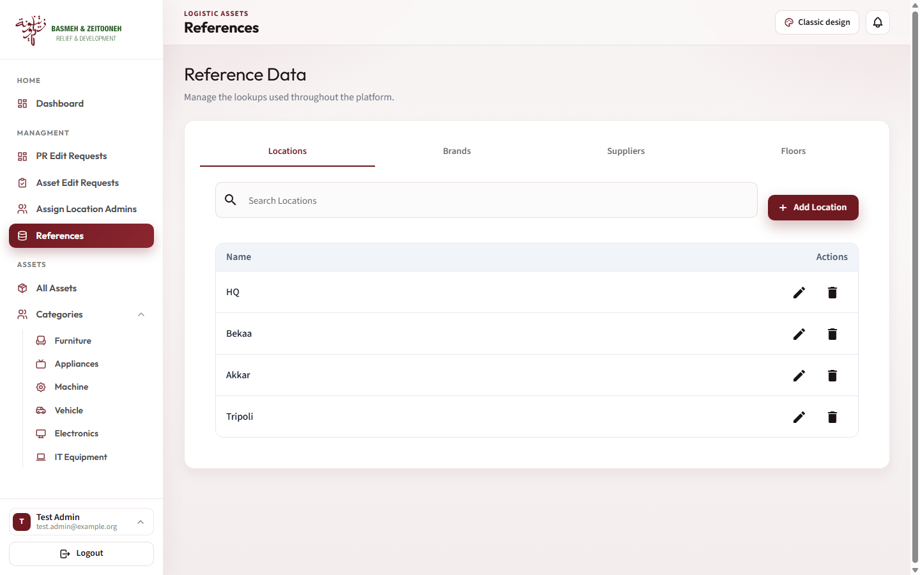

Donors (finance)
In the Donors portal, Donors lists every donor with account number, department, finance officer, areas and end date.
- Add Donor: name, account number, department, finance officer, areas (locations), end date, notes, and any number of policies.
- Donor page: shows the details and policies, and holds the donor's documents (upload PDF, DOC or DOCX up to 10 MB; delete with the bin icon).
- A donor linked to assets cannot be deleted.
The donor and its policies then appear on the assets it funds. Finance users can also open the Dashboard and All Assets, read-only.
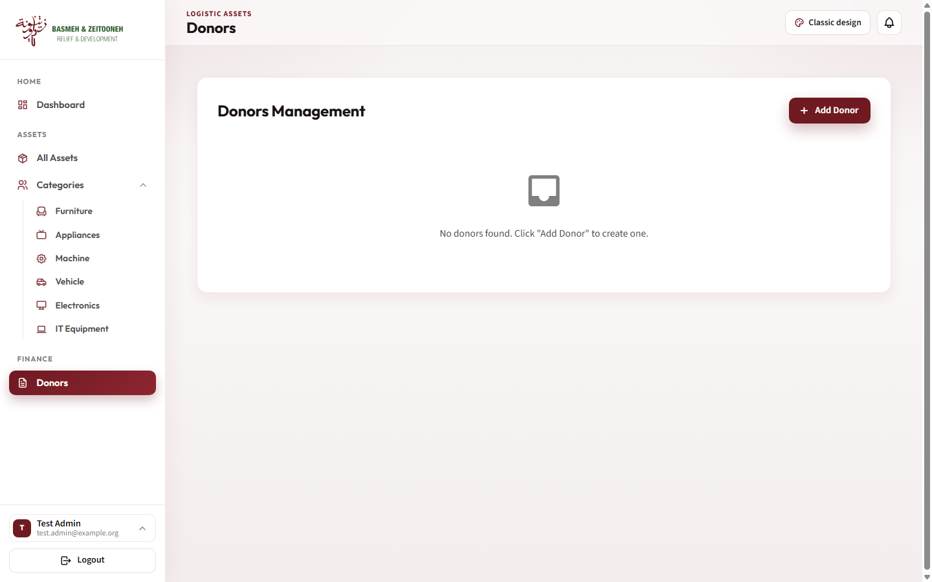

Screenshots: designs and phone
Both designs show the same screens and data; only the look changes. All screenshots in this document use sample data and a test account, not real assets.

Dashboard
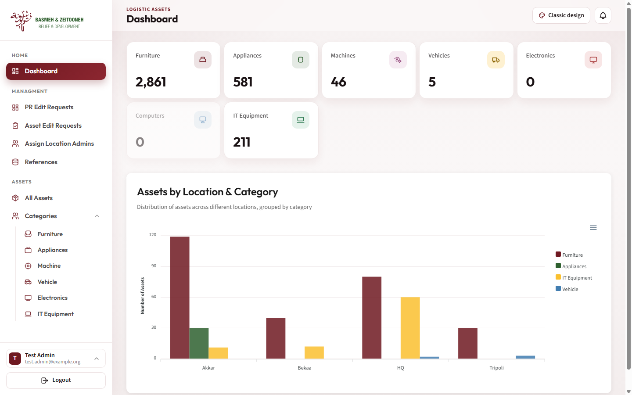
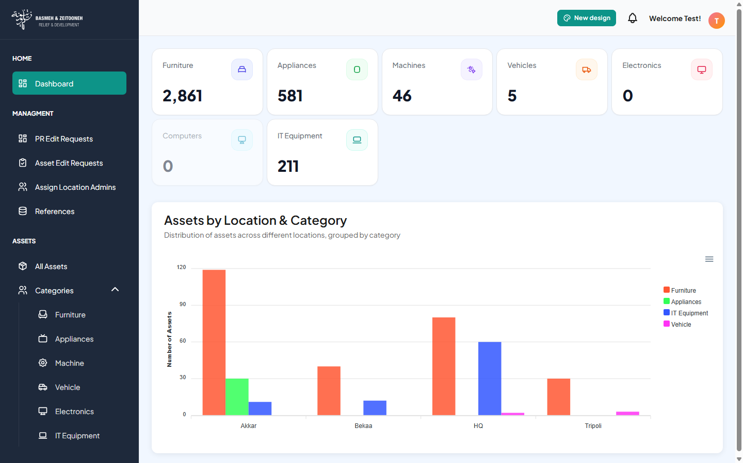

Assets list
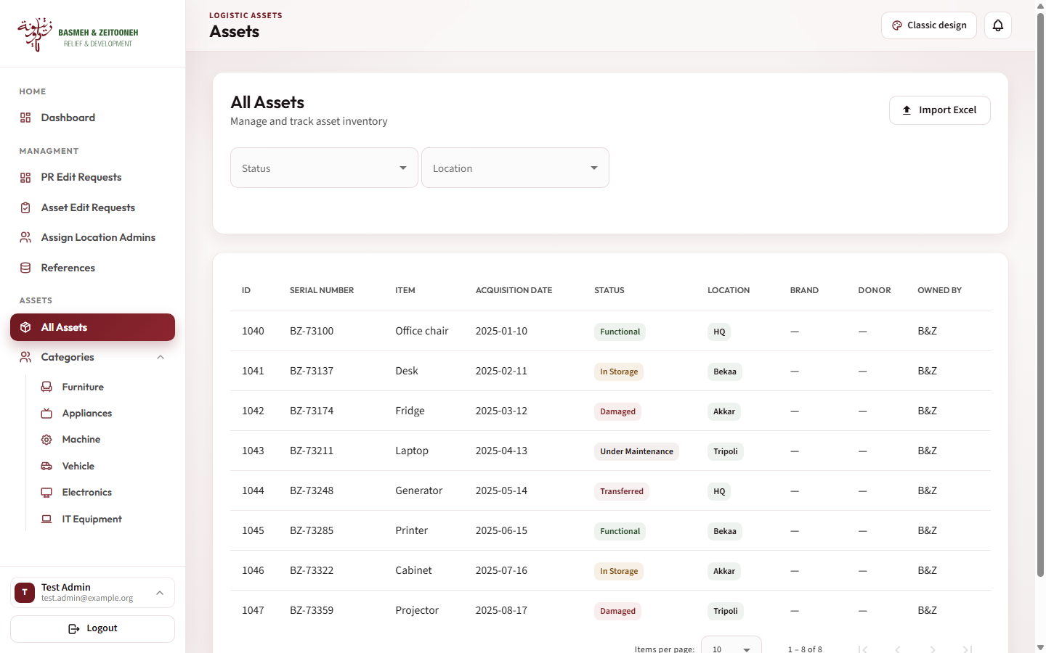
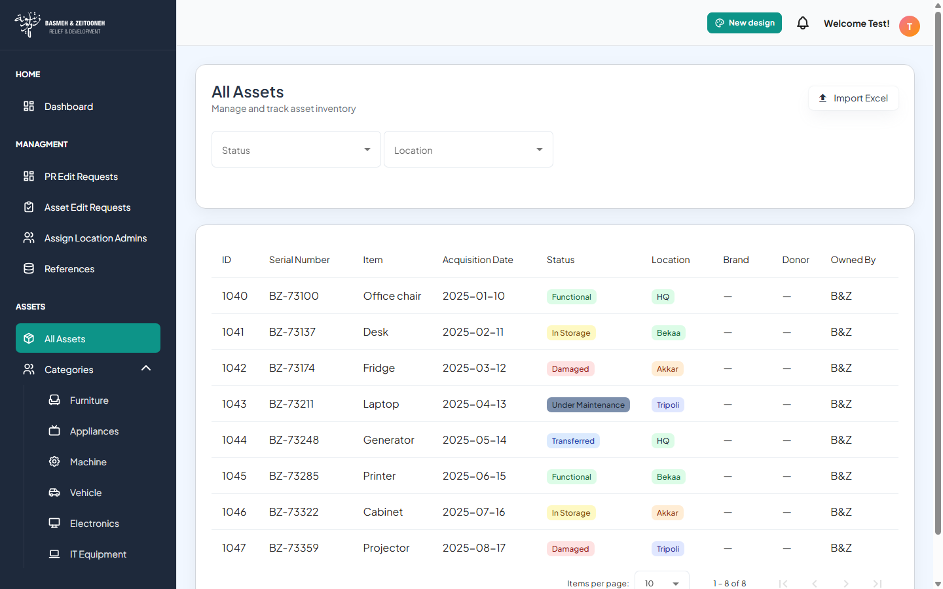

On a phone
The dashboard on a phone (left) and the menu opened with the top-left button (right), BZ design.
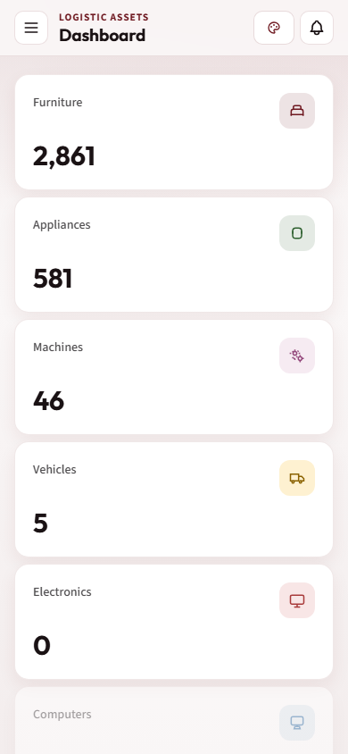
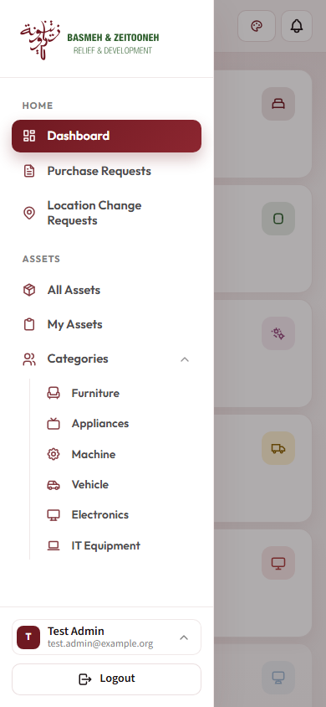

Technical guide
The system is an Angular 15 single-page app calling a Laravel 12 REST API backed by MySQL; one frontend build serves both portals. Code lives in one repository (github.com/developer-bz-2025/logistics-system, branch main).
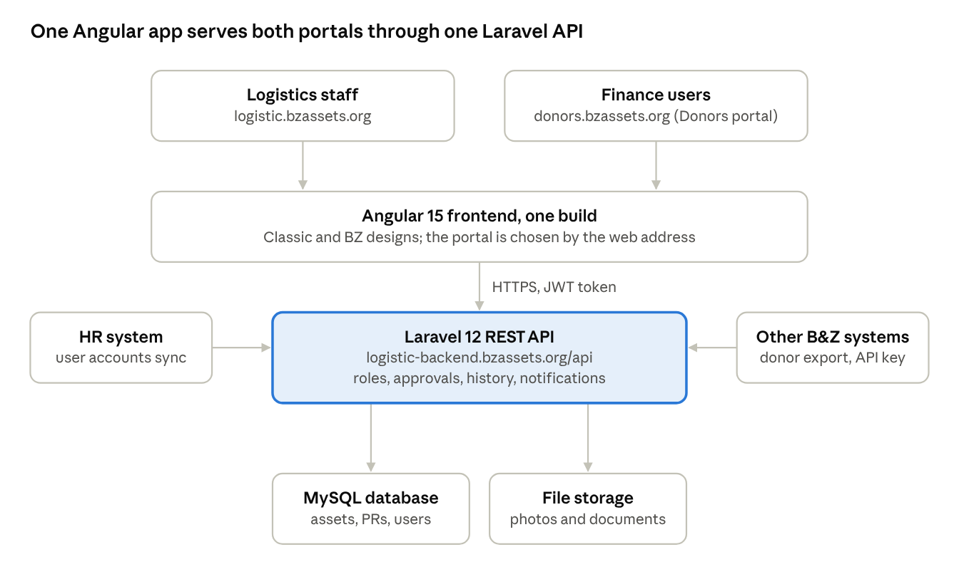
System architecture · 2 portals, 1 API
Both portals load the same frontend, which talks only to the API; the API owns the database and files, pulls user accounts from HR, and exports donors to other systems.

Stack and hosting
Part | Technology | Where it runs
Frontend | Angular 15, Angular Material 15, Tailwind CSS 3, ApexCharts; based on the Modernize admin template | logistic.bzassets.org and donors.bzassets.org (same build)
Backend API | Laravel 12 on PHP 8.2+; JWT auth (php-open-source-saver/jwt-auth), PhpSpreadsheet, Intervention Image | logistic-backend.bzassets.org/api
Database | MySQL (migrations and seeders use MySQL-only SQL) | Hosting provider
Files | Laravel public disk, served through GET /api/storage/{path} | Backend server
Repository folders: backend (Laravel API), frontend (Angular app), Docs (requirements documents, Excel import files, catalog seed stracture.json), bz-design-system (brand tokens and logos).

Running locally
Backend (needs PHP 8.2+, Composer, MySQL):
- cd backend, then composer install
- Copy .env.example to .env and set DB_CONNECTION=mysql with DB_HOST, DB_PORT, DB_DATABASE, DB_USERNAME, DB_PASSWORD
- php artisan key:generate, then php artisan jwt:secret
- php artisan migrate, then php artisan db:seed (the first seeder syncs users from the HR API, so it needs network access; the catalog seeder reads ../Docs/stracture.json)
- php artisan storage:link, then php artisan serve (API at http://127.0.0.1:8000)
Frontend (needs Node.js and the Angular CLI):
- cd frontend, then npm install (legacy peer deps are enabled in .npmrc)
- ng serve, then open http://localhost:4200
No seeder creates a super admin. After seeding, give your own user a role directly in the database (users.role_id).

Configuration
- Frontend: src/environments/environment.ts (development) and environment.prod.ts (production) hold apiBaseUrl, fileBaseUrl, donorsPortalHost (donors.bzassets.org), appTitle and defaultTheme ('bz' or 'classic').
- Backend .env: database, APP_KEY, JWT_SECRET, APP_TIMEZONE (Asia/Beirut). Add EXTERNAL_API_KEY to enable the external donors API; it is missing from .env.example.
- CORS (config/cors.php) allows localhost:4200, logistic.bzassets.org and logistic-backend.bzassets.org. Add donors.bzassets.org there if the Donors portal calls the API from its own host.

Authentication and roles
- POST /api/login returns a JWT; the app sends it as a Bearer token on every request. Tokens last 60 minutes and are renewed through POST /api/refresh.
- Roles live in the roles table (super_admin, log_admin, pr_admin, finance), one per user via users.role_id. Logistics admins are linked to locations through user_locations.
- Middleware: jwt.auth (signed-in user), super.admin, finance.role, logistics.admin.pr.access (limits PRs to the admin's locations). Other role checks sit inside the controllers.

API overview
All paths are under /api.
Area | Endpoints | Access
Auth | POST /login, /refresh, /logout, /change-password; GET /me | Login and refresh public; rest signed in
Assets | GET /items (filters, paging), /items/{id}, /items/{id}/history; POST /items; PUT /items/{id} (creates an edit request); POST /items/{id}/photo; GET /log-admin/assets; GET /finance/assets | Writes: log admin. Finance list: finance
Import | POST /import/assets (xlsx/xls, up to 50 MB) | Signed in
Catalog | GET /categories, /categories/{id}/sub-categories, /sub-categories/{id}/fixed-items, /categories/{id}/attributes, /catalog/structure | Public, read-only (catalog is seeded)
Purchase requests | GET/POST /prs; GET /prs/{id}; POST /prs/{id}/pr-edit-requests; GET /prs-for-asset-creation | Signed in; log admins limited to their locations
PR edit requests | GET /pr-edit-requests, /pr-edit-requests/{id}; POST /{id}/approve, /{id}/reject | Signed in
Asset edit requests | GET /item-edit-requests, /item-edit-requests/{id}; POST /{id}/approve, /{id}/reject | Super admin
Location change requests | GET/POST /location-change-requests; POST /{id}/approve, /{id}/reject | Log admin
Location admins | GET /super-admin/log-admins, /super-admin/log-admin-candidates; POST /super-admin/log-admin-assignments | Super admin
Reference data | GET /statuses, /colors, /locations, /brands, /suppliers, /floors; POST/PUT/DELETE on locations, brands, suppliers, floors | Reads public; writes super admin
Notifications | GET /notifications, /notifications/unread-count, /notifications/{id}; PUT /{id}/read, /mark-all-read; DELETE /{id} | Signed in, own notifications only
Dashboard | GET /dashboard/stats, /dashboard/assets-by-location-category, /dashboard/log-admin-stats | Stats public; log-admin stats log admin
Donors | GET/POST /finance/donors; GET/PUT/DELETE /finance/donors/{id}; GET/POST /finance/donors/{id}/documents; DELETE /finance/donors/{id}/documents/{docId} | Finance
External API | GET /v1/external/donors (?updated_since=), /v1/external/donors/{id} | X-API-Key header, 60 requests a minute
The external API is documented in backend/docs/external-api.md: one full sync, then incremental syncs with updated_since every 15 to 30 minutes.

How the main workflows behave on the server
- Asset edits are never applied directly. PUT /items/{id} records the differences as a pending asset edit request (409 if one is already pending, 422 if nothing changed) and notifies all super admins. Approval applies the changes in one transaction and records them in the asset history.
- Location changes move the asset immediately when the current and new locations share a logistics admin. Otherwise a pending request goes to the new location's admin, who approves or rejects it.
- PR edit requests compare the submitted lines with the current ones (add, delete, change supplier, change cost), notify all super admins, and on approval update the PR, its document and its totals.
- Every change writes an asset history entry and an activity log row. Notifications are in-app only; no email is sent.

Excel import format
One worksheet per category, titled exactly as the category (sheets named suppliers, Category N or REF_ are skipped). Row 1 holds the headers, matched without regard to case:
Category, Sub Category, Item, SN, Description, Brand, Color, Supplier, Status, Acquisition Date, Acquisition Cost, Warranty Start Date, Warranty End Date, Budget Code, Budget Donor, Location, Floor, Notes, Owned By (B&Z or Landlord), plus one column per category attribute.
- Sub-category and item must already exist in the catalog, or the row is skipped.
- Unknown brand, colour, status or location is left empty; an unknown supplier becomes "N/A".
- A row whose serial number (SN) already exists updates that asset; rows without an SN are always added.
- The import reports how many rows were added, updated and skipped, plus duplicate serial numbers.

Files
File | Stored at | Limit
Asset photos | items/photos (compressed to about 100 KB JPEG) | 10 MB upload
PR documents | prs/ (edit-request files wait in pr_edit_requests/) | 20 MB; PDF or image
Donor documents | donors/documents/ | 10 MB; PDF, DOC, DOCX
Imports | storage/app/private/imports | 50 MB

Designs (theming)
The Classic and BZ designs share all screens. The toggle adds the class theme-bz to the page, and every BZ style lives under html.theme-bz in frontend/src/assets/scss/themecolors/_theme_bz.scss (Material colours in _theme_bz_material.scss). The choice is stored in the browser under the key app-theme. Brand colours, fonts and logos come from the bz-design-system folder.

Build and deploy
- Frontend: ng build (production by default, uses environment.prod.ts) writes to dist/Modernize. netlify.toml rewrites every path to index.html, which any static host needs for this app.
- Backend: deploy the Laravel app, run php artisan migrate, and keep storage/app/public writable.
- There is no CI pipeline, Docker setup or server configuration in the repository; deployment is manual.

Known issues for developers
- PR edit request approve and reject, PR creation and Excel import check only that a user is signed in, not their role.
- Several read endpoints are public, including GET /users (all users with emails and roles), /items and /api/storage.
- .env.example defaults to SQLite and lacks JWT_SECRET and EXTERNAL_API_KEY, although the app needs MySQL.
- Credentials are committed to the repository (HR API keys in SyncEmployees.php, hosting accounts in Docs/host.txt). Rotate them and remove them from history.
- Unused code: asset export, import template download, the maintenance module and the asset PDF service have no routes.
Frontend gaps found while writing this document:
- Logout links only navigate to the sign-in page; they never call auth.logout(), so tokens stay in localStorage.
- Sub-pages under /dashboard (references, edit requests, my-assets) declare roles in route data but no guard checks them; only the menu hides them.
- The PR detail page (/pr/:id) is empty, and the header's /search navigation has no route.
- The PR create hint says "PDF, DOCX, PNG up to 10MB" while the API accepts PDF, JPG, JPEG or PNG up to 20 MB; the asset photo check stops at 5 MB while the API allows 10 MB.
- After a PR edit request, the toast reads "PR updated successfully"; the PR edit rejection reason field is commented out.
- Change Password redirects to /dashboard, which PR admins cannot open, and the PR create Back link also points there.
- The dashboard chart falls back to hard-coded sample data when its API call fails.
- Asset list filters for search, floor, supplier and holder are commented out, and Import Excel shows for every role.
- Statuses "In Storage" and "Under Maintenance" are styled in the UI but not seeded in the status table.

Troubleshooting and FAQ
Most surprises come from the approval step or from role and location limits; the answers below cover what users ask most.
Question or problem | Answer
I edited an asset or a PR but nothing changed. | Edits are requests. They apply only after a super admin approves them; a banner on the asset shows it is pending. The PR form's "PR updated successfully" message also means the request was sent, not applied.
Edit Asset and Move Asset are greyed out. | Only the logistics admin of the asset's location can change it, and only one pending edit or move is allowed per asset. Super admins and finance see assets read-only.
A purchase request is greyed out when I create an asset. | Every line of that PR is already linked to an asset. Ask for a new PR, or an edit to add lines.
My PR document is refused. | New PRs accept PDF, JPG or PNG up to 20 MB (the on-screen hint mentioning DOCX is wrong). A replacement document on an edit accepts PDF, DOC or DOCX up to 10 MB.
Rows were skipped in my Excel import. | Each sheet must be named exactly like a category, and every row's sub-category and item must already exist in the catalog. Check the skipped list the import reports.
A menu item or page I expect is missing. | Pages depend on your role. Ask a super admin to check your role and, for logistics admins, your assigned locations. Changes apply at your next sign-in.
I selected Logout but the app opens straight into my account next time. | On the main site, Logout currently returns to the sign-in page without ending the session. On a shared computer, close the browser or clear this site's data until this is fixed.
After changing my password (PR admin) I landed on the sign-in page. | Expected for now: sign in again with your new password.
Selecting a notification does nothing. | Notifications are messages only; open the asset or request from the menu.
Opening a PR shows a blank page. | The PR detail page is not built yet. Use View Items and View Document in the list.
I cannot delete a donor. | Donors linked to assets cannot be deleted.
The dashboard chart shows locations that look wrong. | If the chart's data fails to load it shows built-in sample figures. Refresh the page.
The colours or layout look different from a colleague's. | You are on different designs. Use the design button in the top-right corner; the choice is saved per browser.
For access, roles and locations, contact a super admin. For errors and anything else, contact the development team (contact name to be added).

